**MPO 563 Exam -- April 4, 2017 Name: _______________________**

Closed book. 12 points each.

WHICH 8 SHALL I GRADE (4 points)?

1a. (6) Write the First Law of thermodynamics for a parcel of ideal gas, dT/dt = 2 terms. Explain the *two different approaches* (entropy or static energy) for recombining terms to get the one-term (cserved-variable) form, d(something)/dt = Q.

1b. (6) Using one of the approaches above, explain in words the conceptual basis for, and derive the value of, the *dry adiabatic lapse rate*.

2a. (2) What is the most important equation governing fluid flow? (Hint: it makes a fluid different from a set of billiard balls).

2b. (2) What is the second most important equation? (Hint: it involves gravity).

2b. (8) Write these two, and the other 3, to make the entire 5-equation Boussinesq equations set. You may use advective form, or flux form, in scalar form or vector form, but it is ALL OR NOTHING! 0 points if any of your equations is actually incorrect or don’t make sense.

3. (4) What is a *flux,* for instance a flux of butterflies through a net?What are its units?

(2 each) Show (using the units as a guide) what quantity from class is a:

(a) volume flux

(b) mass flux

(c) moisture flux

(d) momentum flux

4a. What is the *job* of pressure perturbations? Explain (4).

4b. (8) Explain and show mathematically how the concept in 4a. allows you to derive an equation mathematically for pressure perturbations π = πbuoy + πdyn = ….

5. Take the inner (dot) product of velocity with the Boussinsq acceleration equations to show that kinetic energy, integrated over the whole of a fluid so that flux diveregnces vanish, obeys ∂/∂t [KE] = [bw] where [] indicates that average over the whole fluid.

6. Match the skew-T with its corresponding static energy diagram. On each matching pair, mark with A and B two corresponding features on each profile. (3 points each):

a. b.

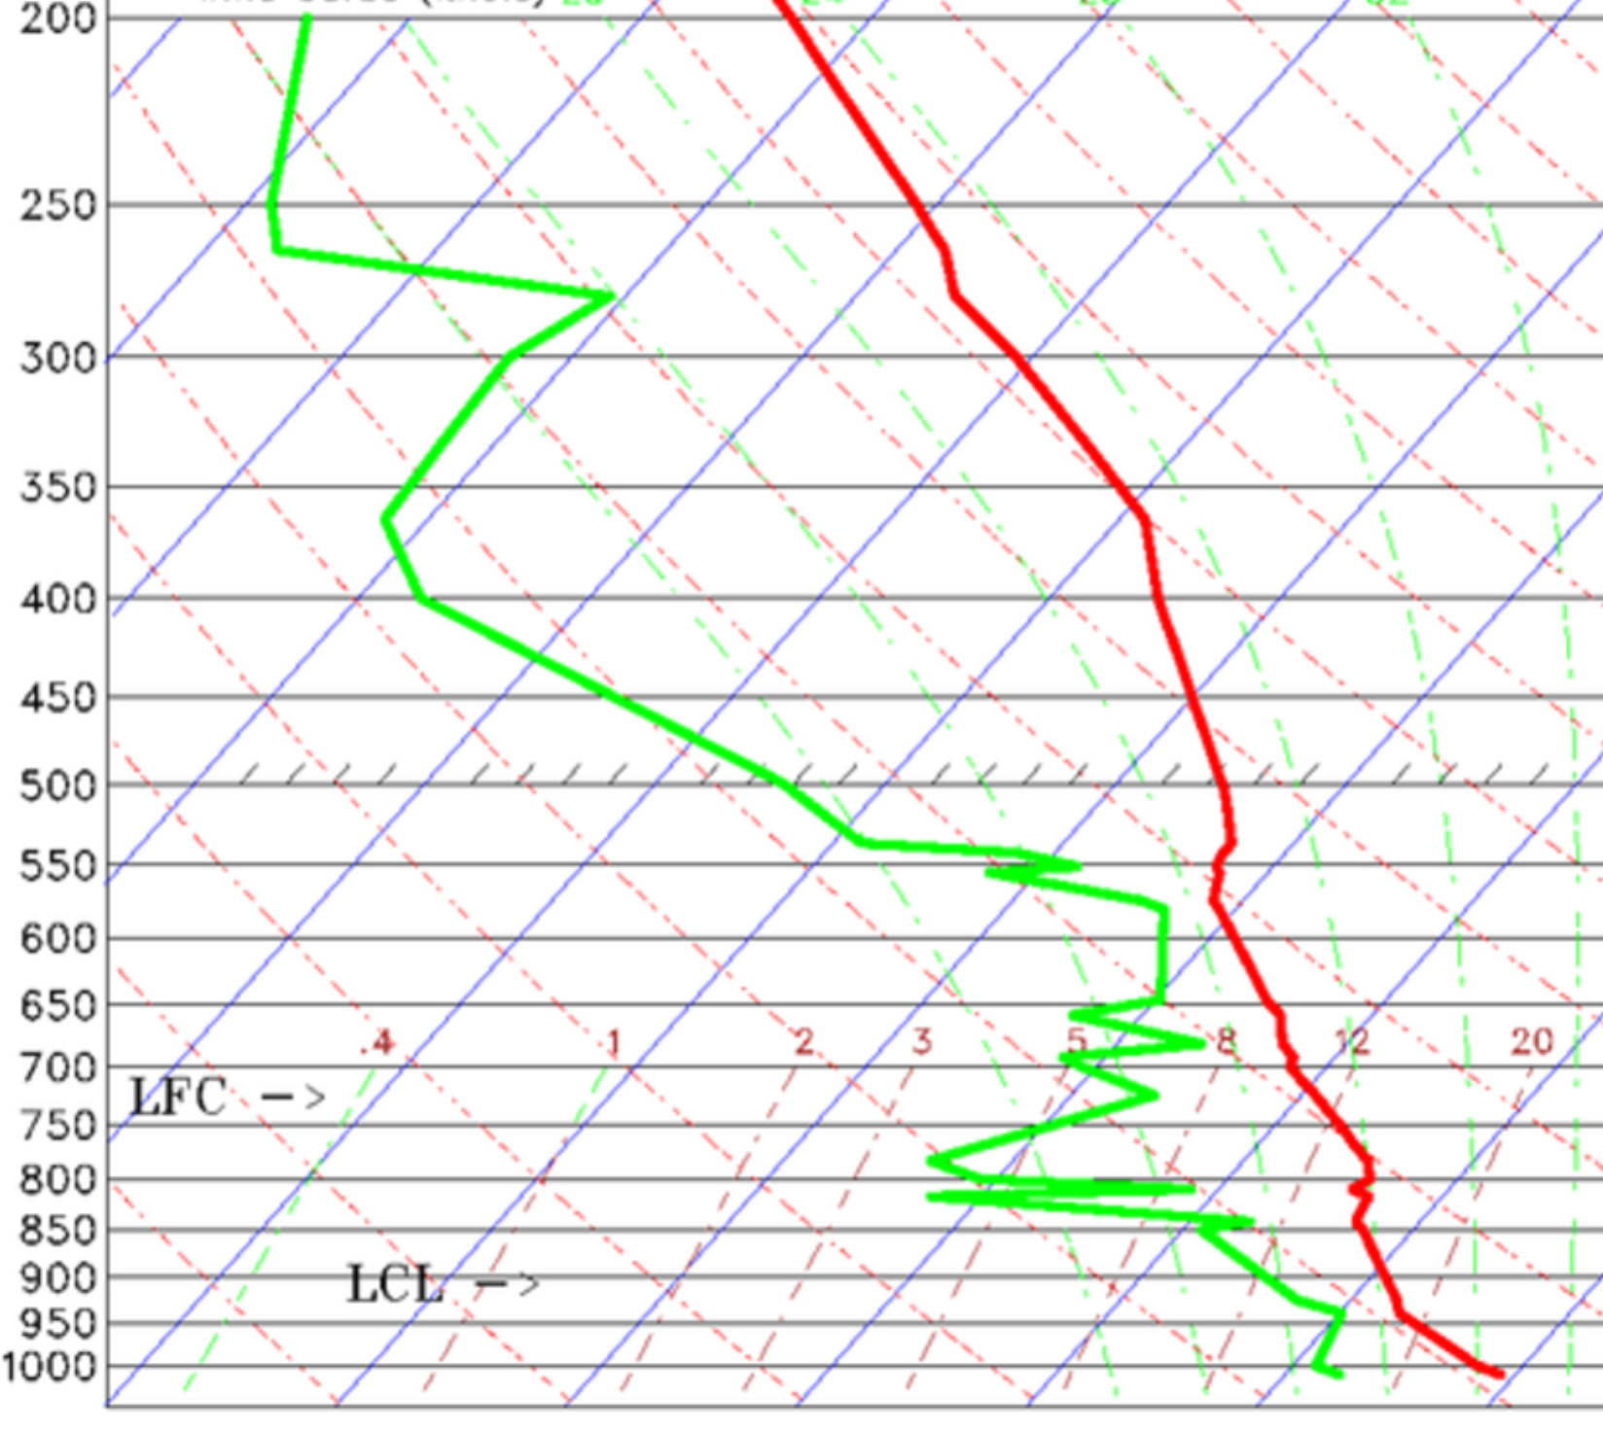 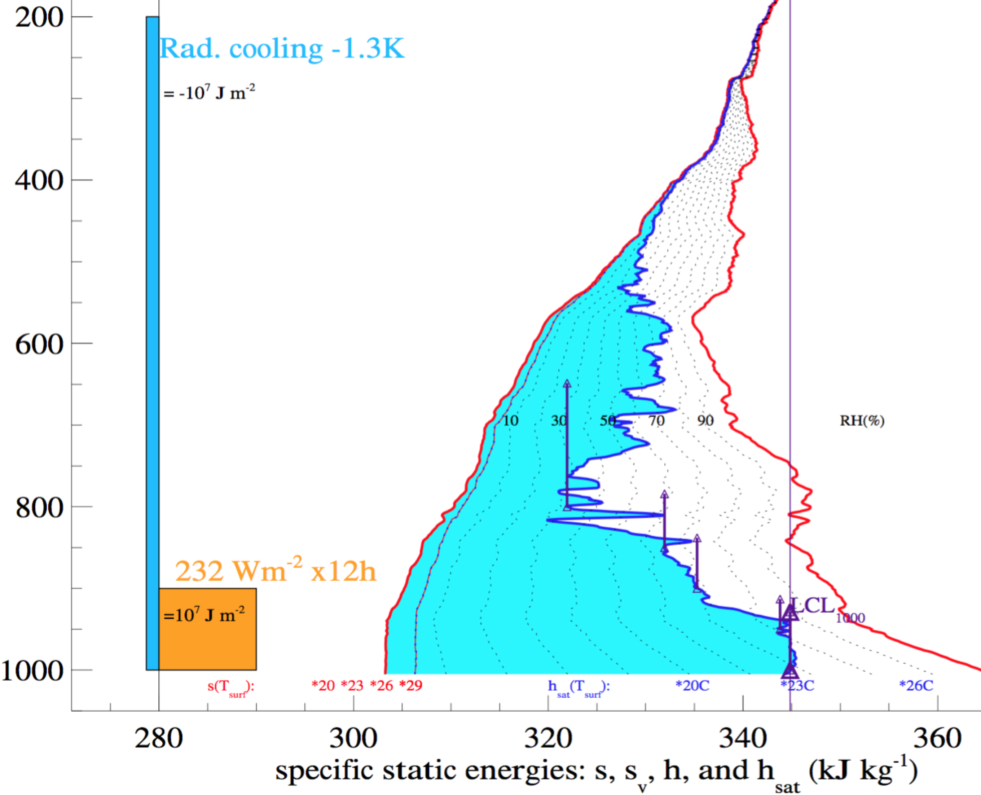

c. d.

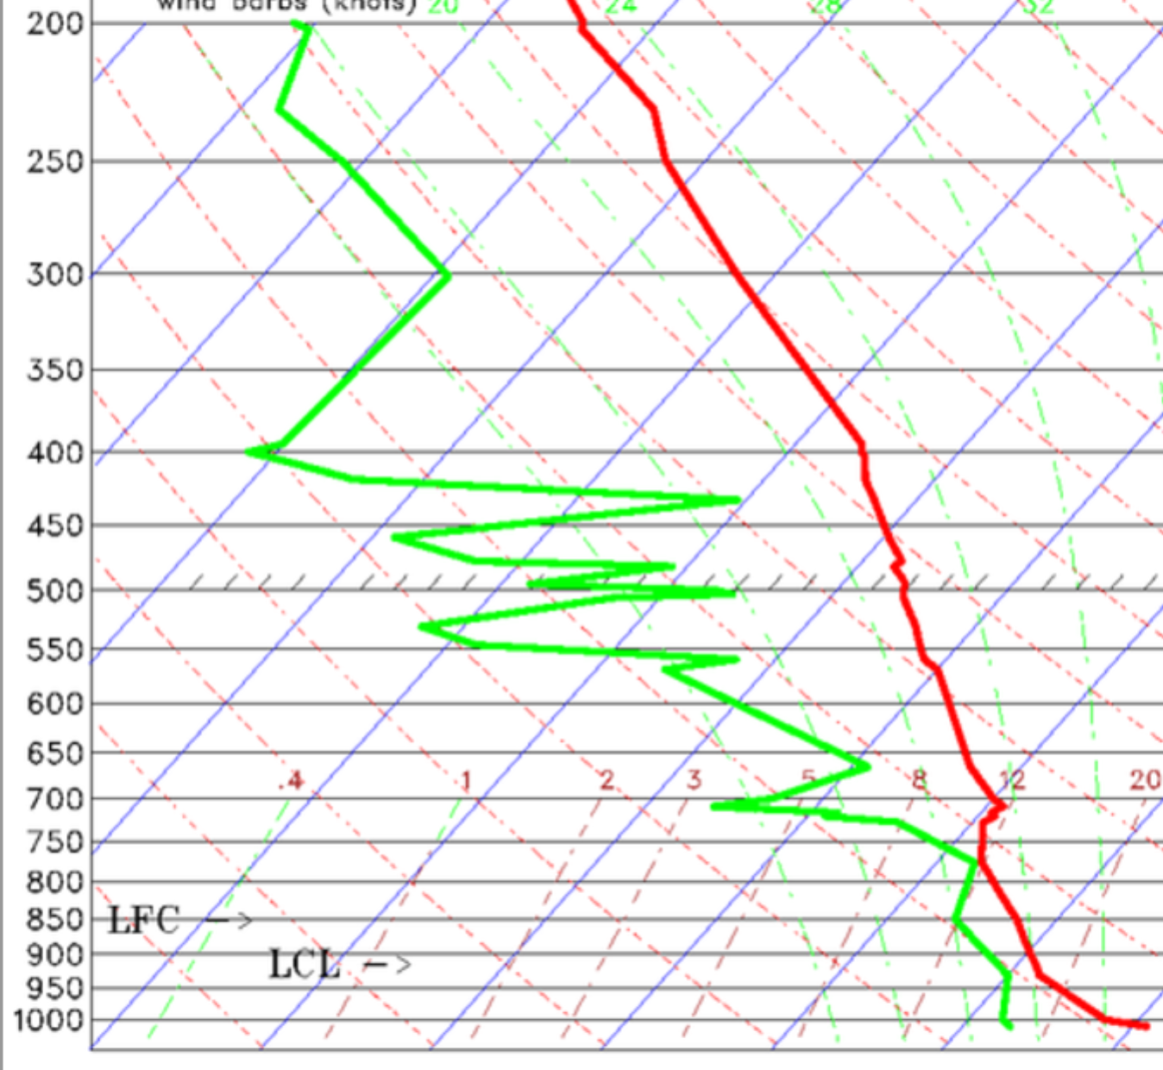 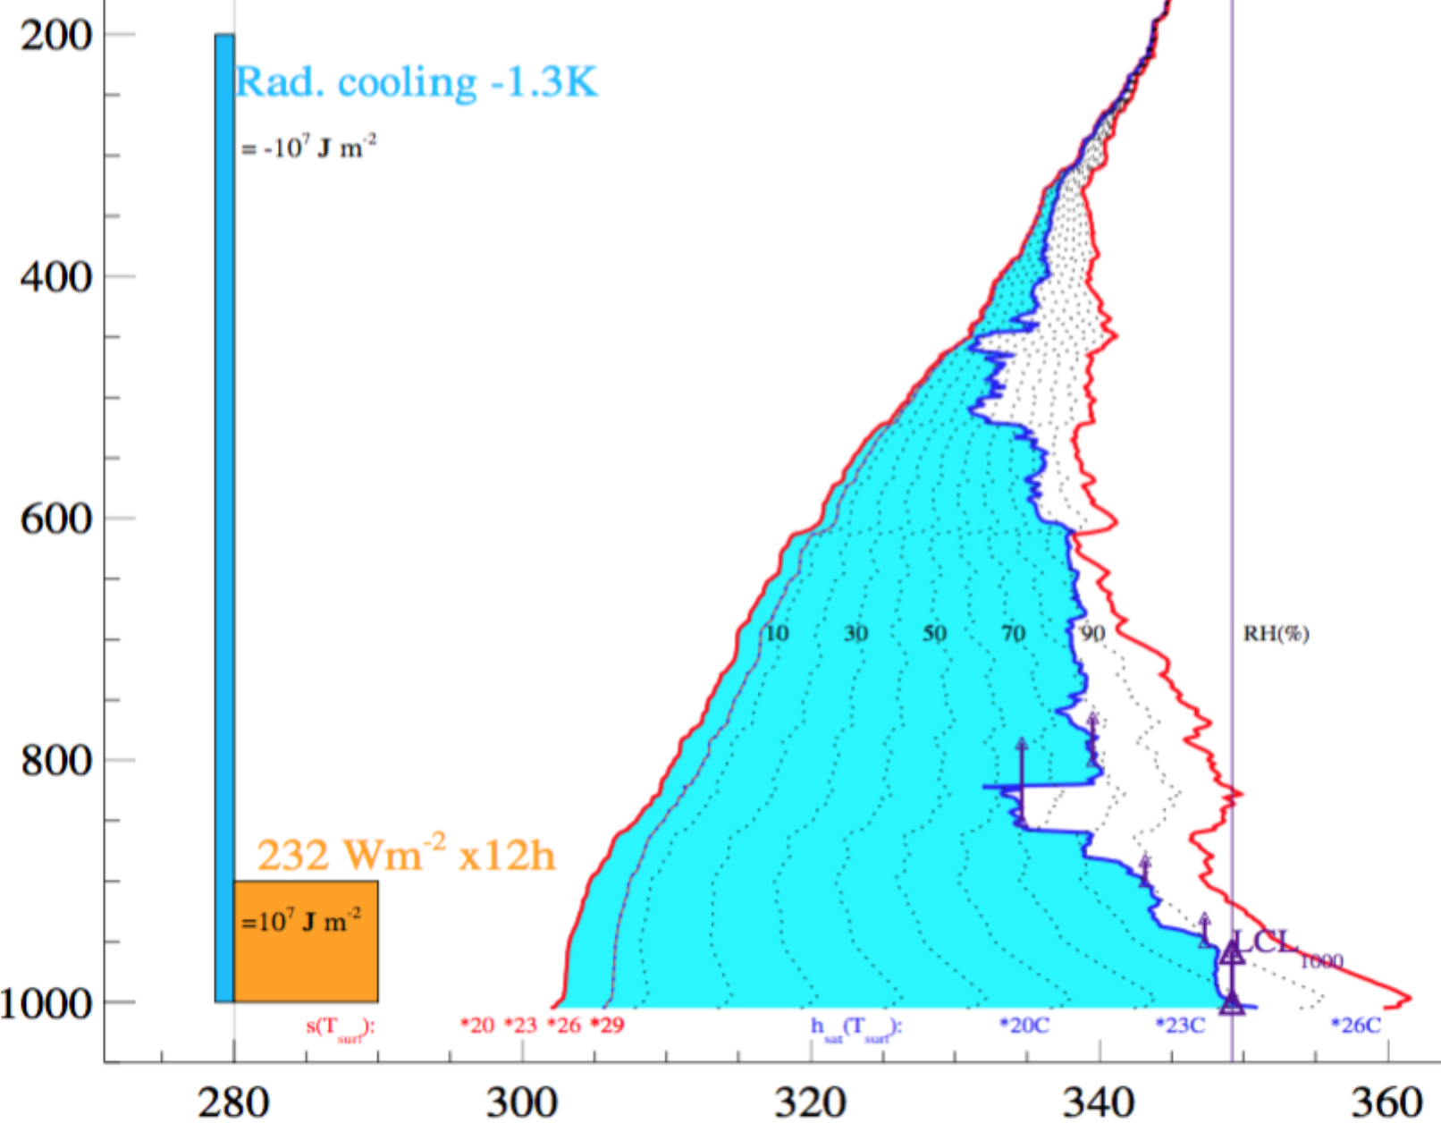

e. f.

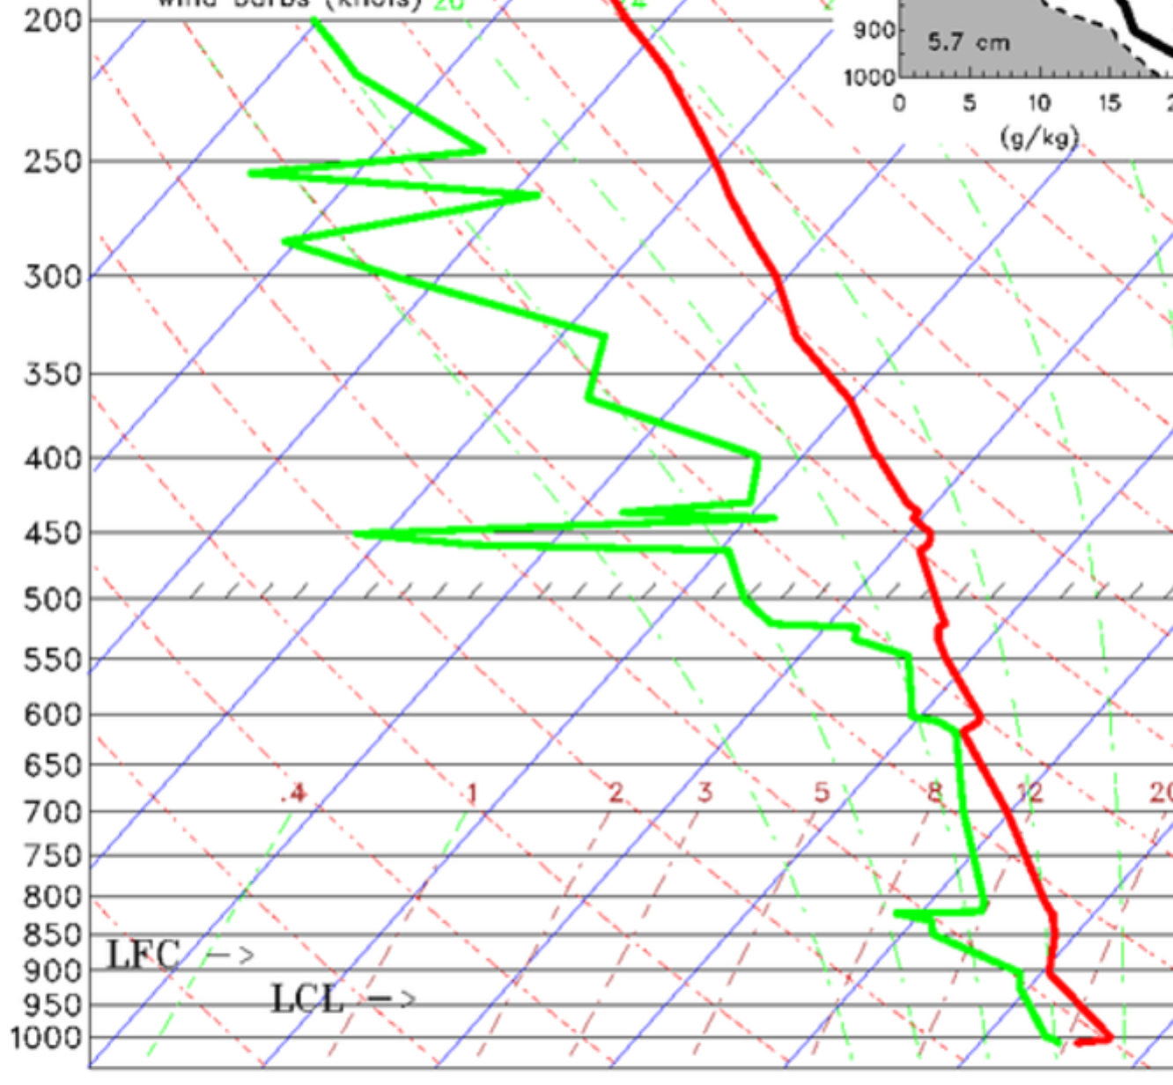 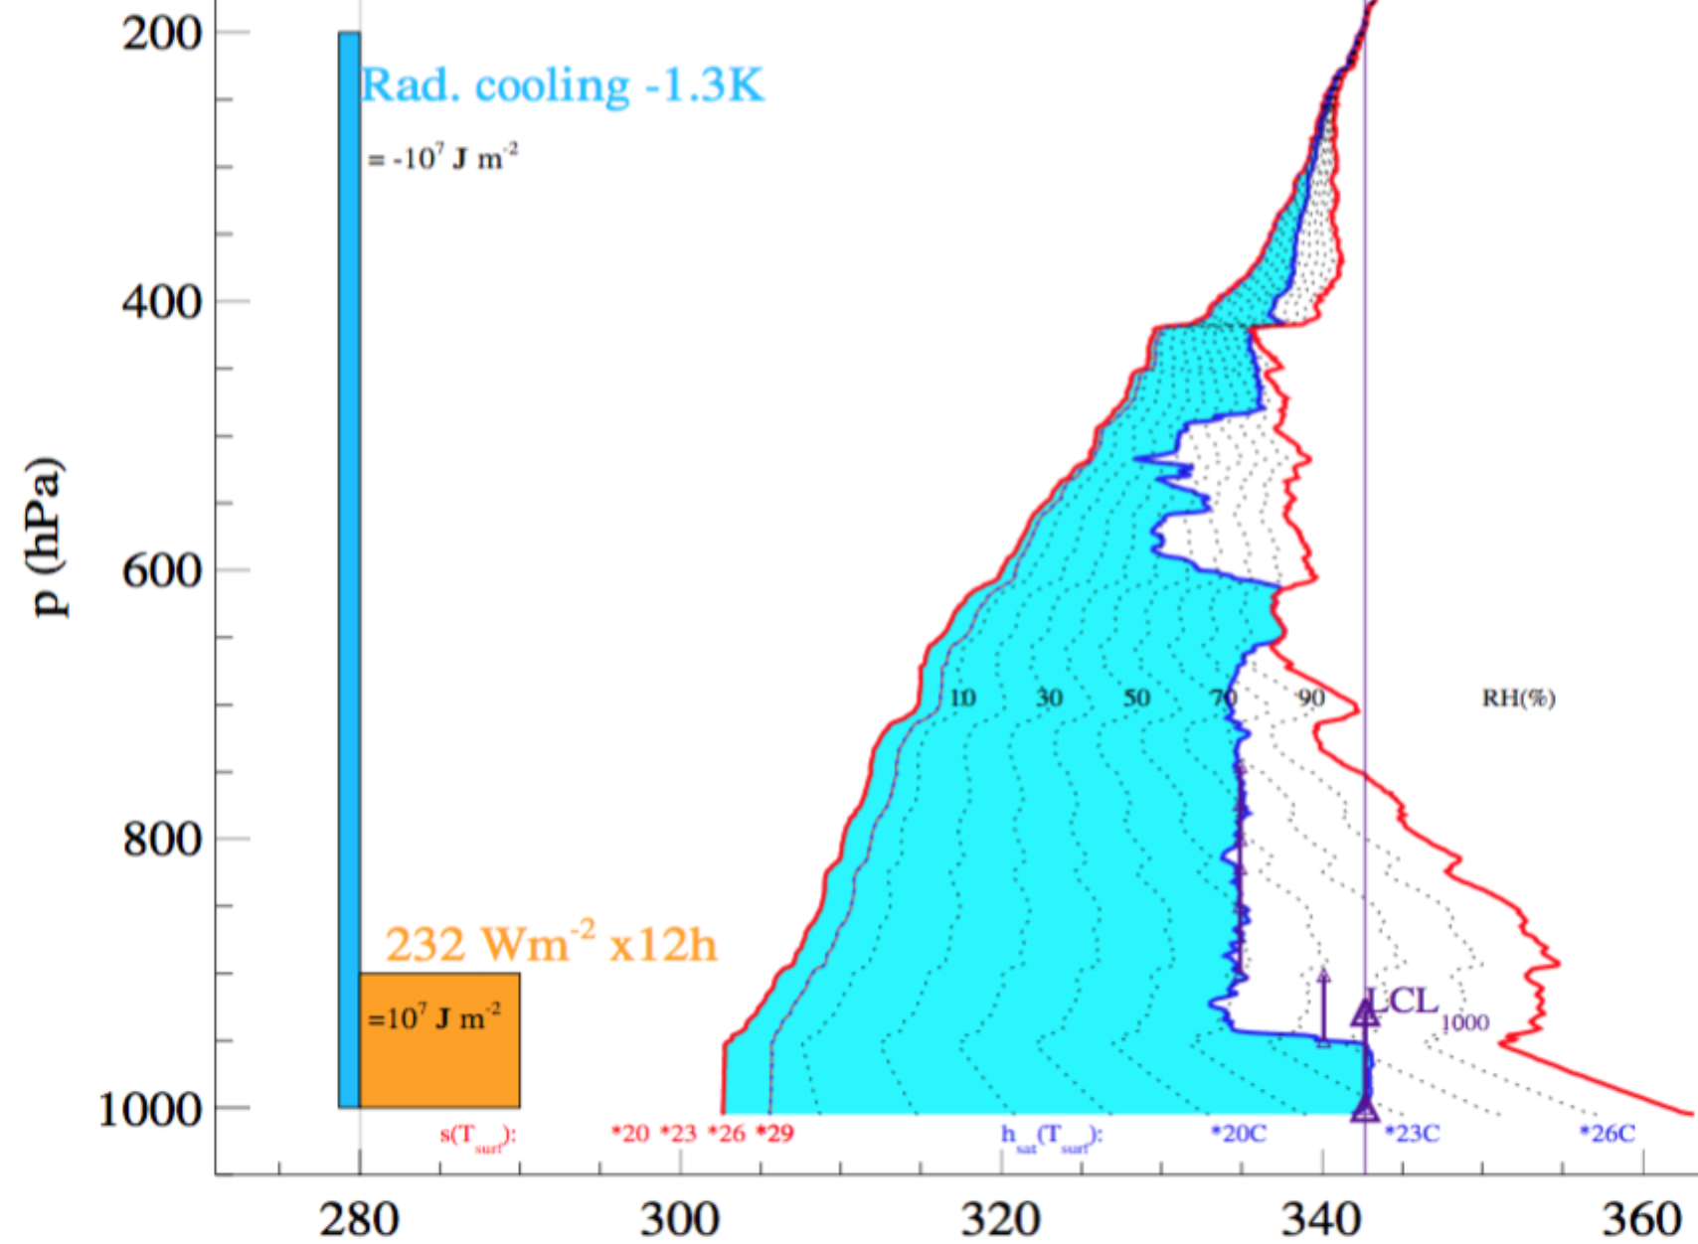

g. h.

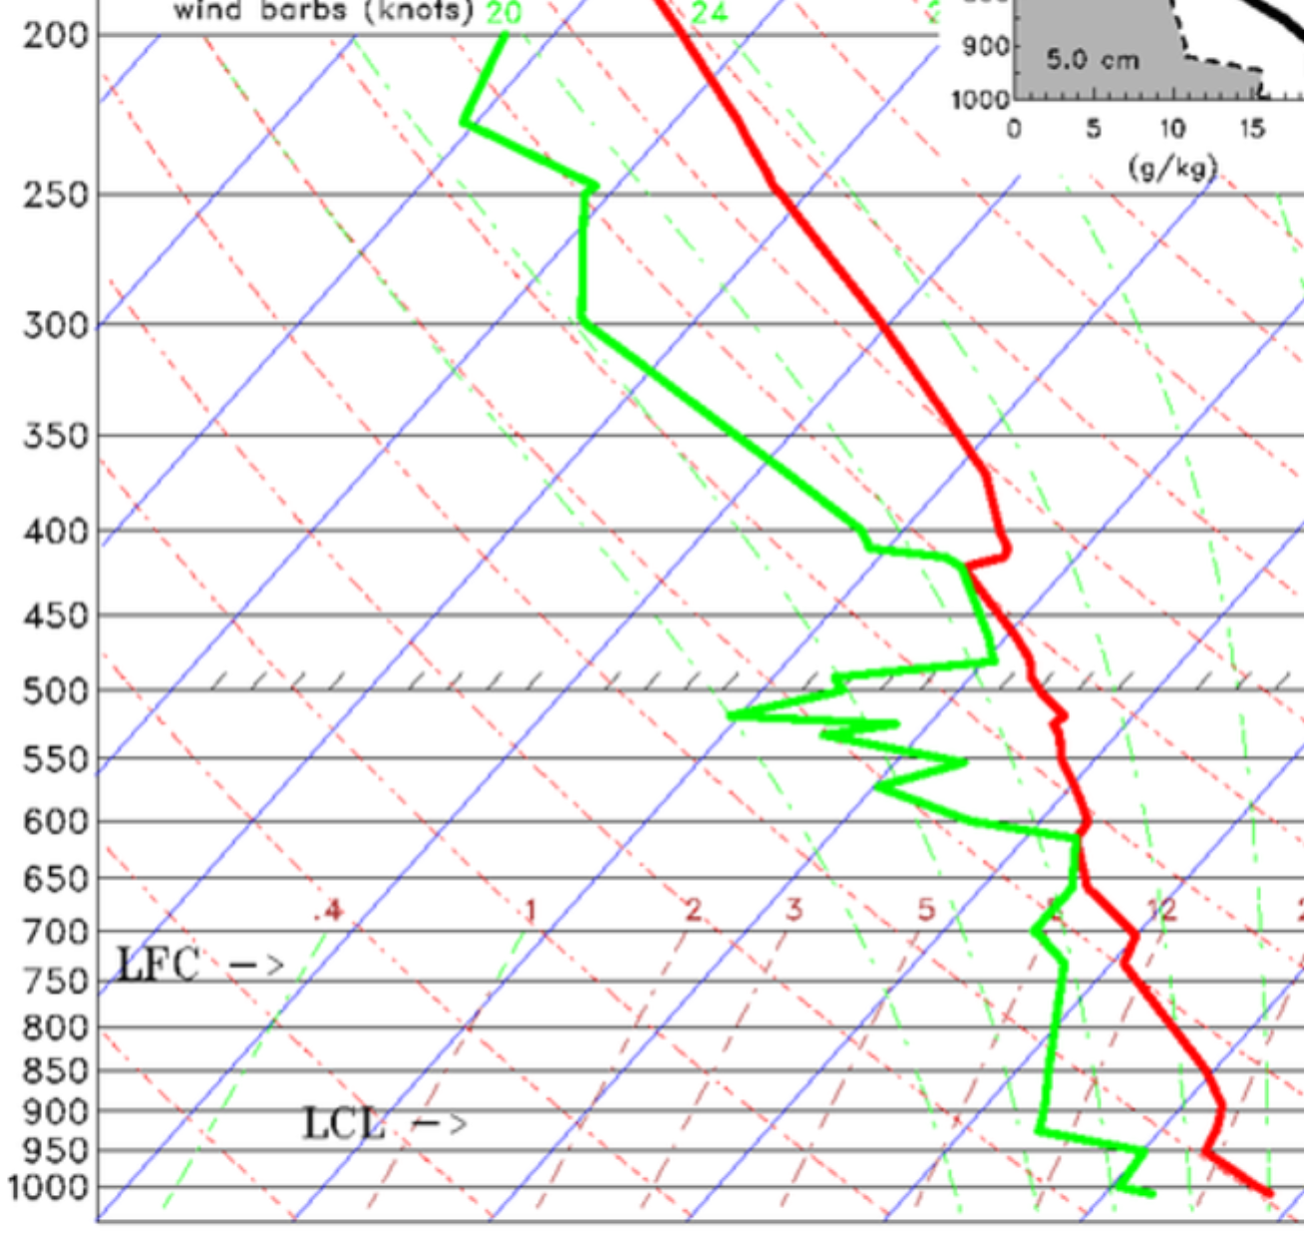 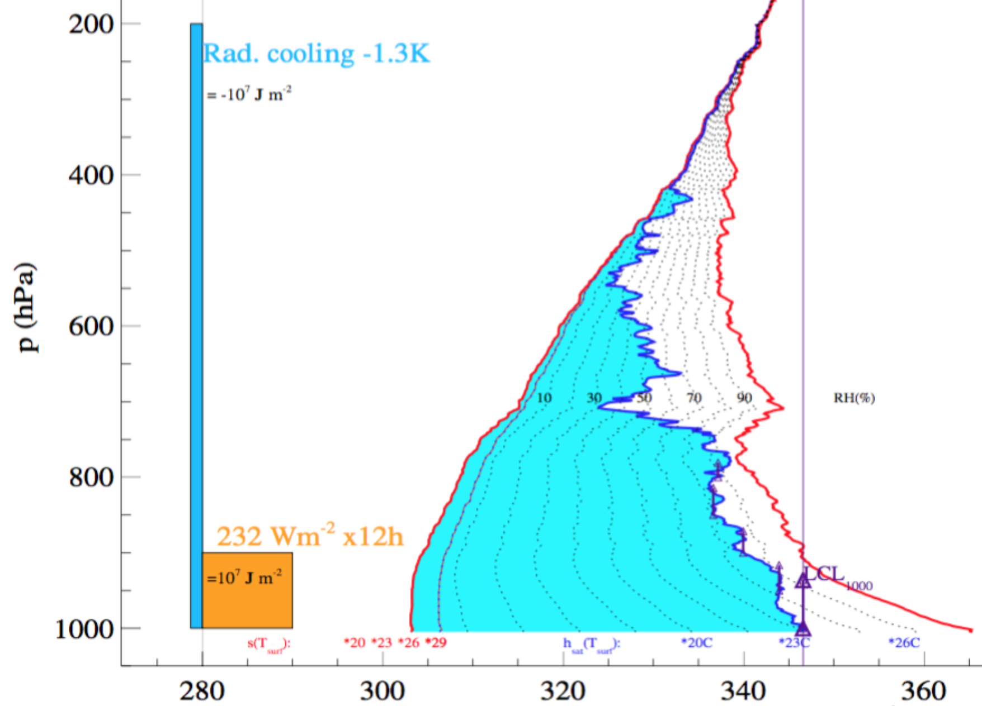7. Energy flux at the bottom of an air column.

a. (4) sketch the effects on the red and blue curves due to 2.5 million J m-2 (1/4 of an orange square worth of energy addition), if the flux is **100% sensible (all heat, no moisture)**. The energy is added slowly enough for dry vertical mixing to keep up, but not for deep convection or other processes to affect the higher altitudes.

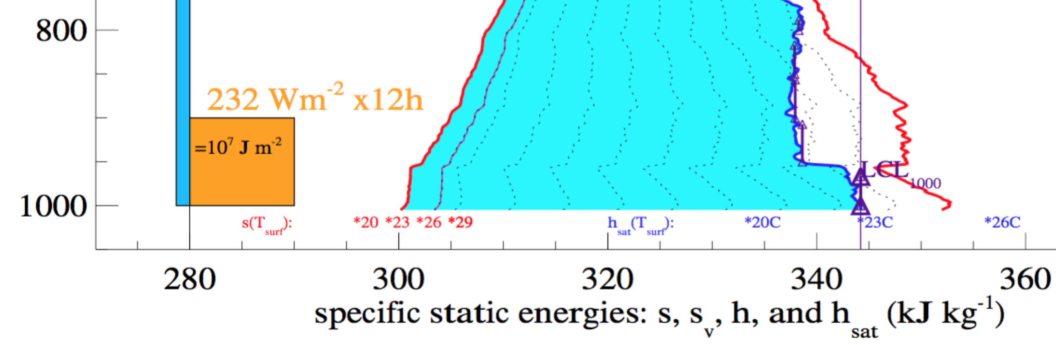

b. (4) sketch the effects on the purple (sv) and blue curves due to 2.5 million J m-2 (1/4 of an orange square worth of energy addition), if the flux is **100% latent (all moisture, no heat)**.



c. (4) Which scenario is better for the possible development of deep convection? Why? Explain. Hint: show that you understand how to estimate the buoyancy of a parcel lifted from near the surface.

8.

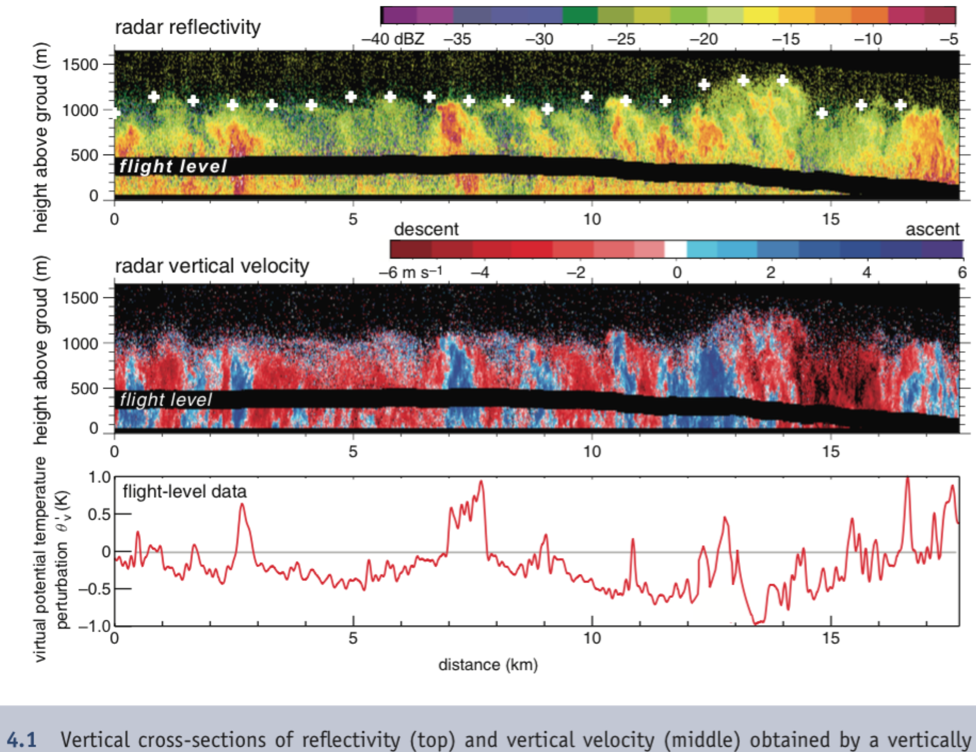

1. (6) Sketch under the figure a graph of the indefinite integral (the cumulative flux from x=0), F(x)= 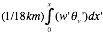. To begin, set the value at the right hand edge of your sketch (at x=18 km) to the total turbulent flux, and label your rough estimate of its value (in K m/s). Start the sketch from F(0)=0. Which contributes more to the turbulent eddy heat flux, hot updrafts or cool downdrafts? What does this imply about the convection here? (bottom-up, heated from below? or top-down, cooled from above?)
2. (6) Recall that d/dt(KE) = [w’b’] where [ ] denotes an integral over the mass of the convecting layer. Since buoyancy b’ = g v’/o, convert your total flux into an estimate of ***how many Joules of turbulent KE*** would be created by 1000 s of the thermally direct turbulence shown in the figure.

9. ***Ageostrophic wind and the low level jet:*** 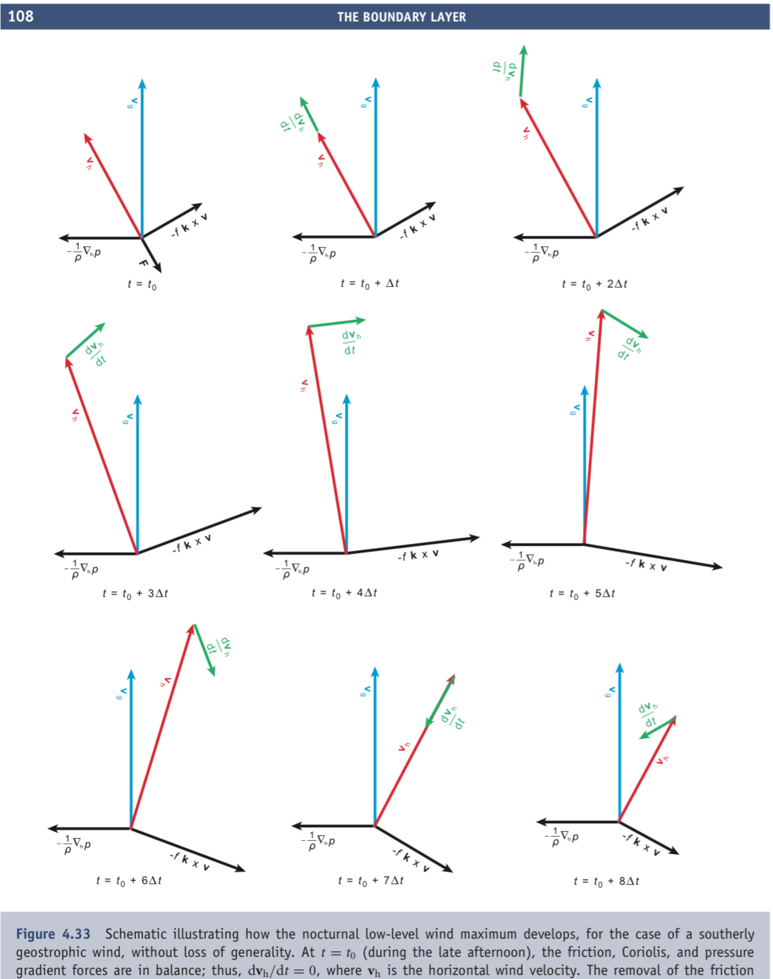

1. (4) Explain the force balance in the first panel, and what happens at time t0.
2. (4) Show that  and  for frictionless flow with the nonlinear advection terms neglected.
3. (4) About how many hours after sunset is the wind speed strongest, if the inertial period (2p/f) is 24 hours?

10. Consider this diagram showing the *net vertical acceleration* ( in our Boussinesq terms) in and around a block of uniformly positively buoyant air (b=0.1 m/s/s) with bumps on top, in neutral (b=0) motionless air where all the advection and inertia effects (that is, the dynamic pressure terms) are zero. What does it imply about why cumulus clouds are bumpy? Explain the chain of reasoning usin concepts like *positive feedback* or *instability*, and refer to the properties of the inverse Laplacian operator.

*Total vertical acceleration (m/s/s) around a block with b=0.1 m/s/s (red area), in a fluid with b=0 everywhere else.*

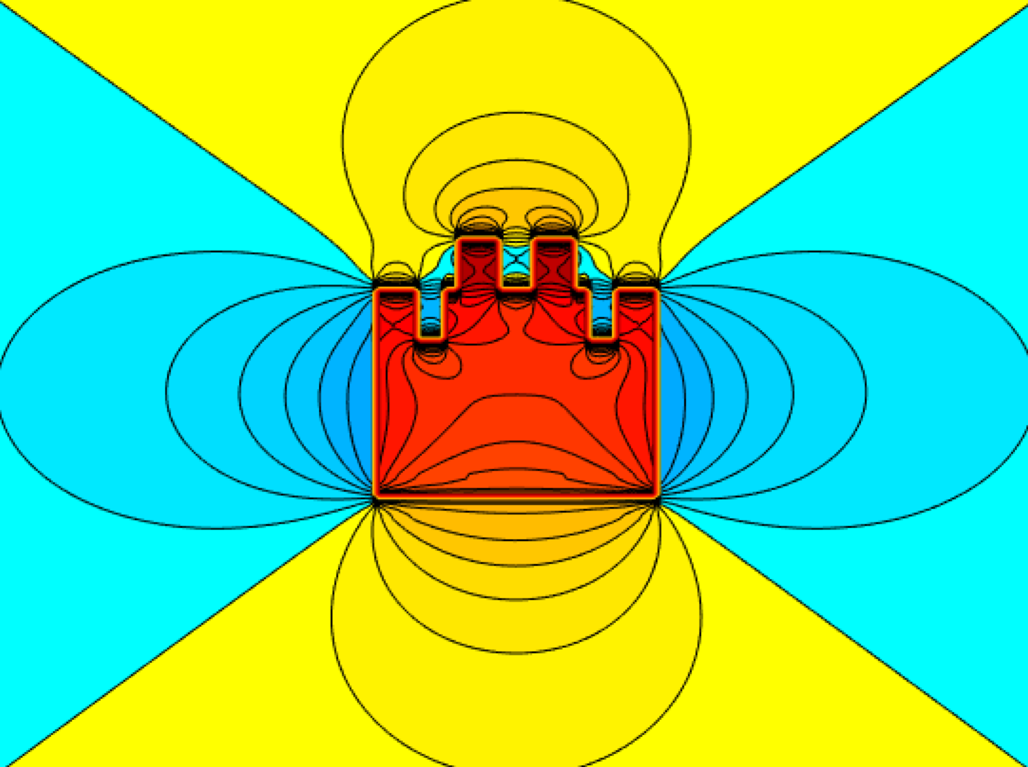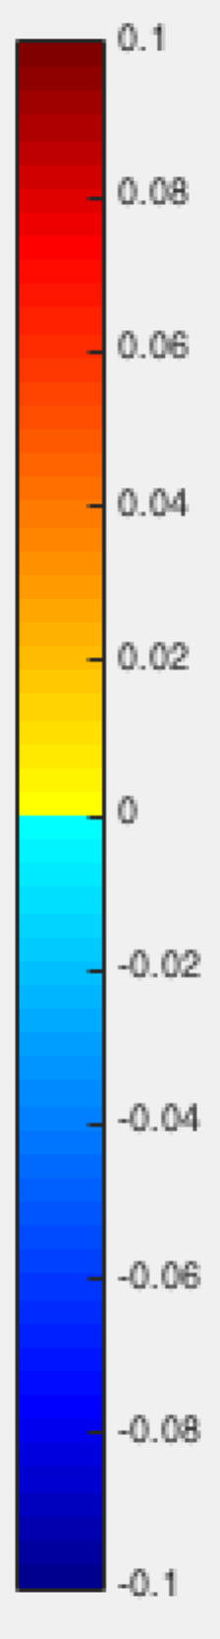

11. Below each twin vortex, make a sketch of thev(x) wind profile along the axis of the vortices, **taking account of both vortices**. The size of these vortex icons denotes their strength. Your curves should approach v=0 as the background limit, far from both vortices.

a. (3)



b. (3)



c (3):



d (3):



12. Why do supercells split? Explain, referring to the features in this diagram. What are the hollow blue tube-arrows? What are the solid blue block-arrows and why are they drawn where they are drawn?

